Course assignment
Student’s name
Institutional Affiliation
Course name and number
Date

1- Jules wants to purchase a Royale with cheese from Vincent. Vincent is willing to offer this tasty burger for $3. The most Jules is willing to pay for the tasty burger is $10 (after all, his girlfriend is a vegetarian, so he doesn’t get many opportunities for tasty burgers).
- How large are the potential gains from trade if Jules and Vincent agree to make this trade? In other words, what is the sum of producer and consumer surplus if the trade happens?
Figure 1
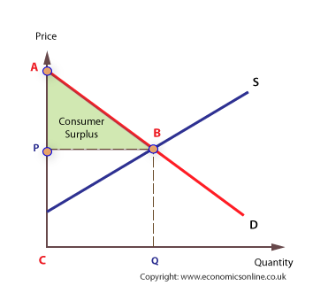
Figure 2
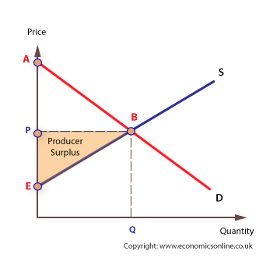

In this case, Jules is the consumer who is willing to purchase A Royale with cheese at $10 but he is able to buy it at only $3. Therefore the consumer surplus here is $10-$3=$7 as represented by area ABP in figure 1 above. On the other sides, Vincent is the producer of the product and he is will to give this offer of A Royale with cheese to Jules at $ 3 but he finally manages to sell it at $10 giving him a producer surplus of $10-$3 =$7. Therefore the sum of producer and consumer from this trade is $7+$7=$14
- If the trade takes place at $4, how much producer surplus goes to Vincent? How much consumer surplus goes to Jules?
If the trade take place at $4 the producer surplus that would go to Vincent will be $4-$3= $1 while the consumer surplus will be $10-$4=$4.
- If the trade takes place at $7, how much producer surplus goes to Vincent? How much consumer surplus goes to Jules?
If the trade take place at $7 the producer surplus that would go to Vincent will be $7-$3= $4 while the consumer surplus will be $10-$7=$3.

2- Consider the following supply and demand table for bread. Draw the supply and demand curves for this market. What are the equilibrium price and quantity?
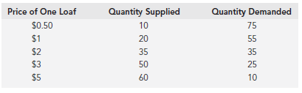
In the graph below the y axis represent price of a loaf in US dollars and on x-axis it is the quantity demanded at a given price.
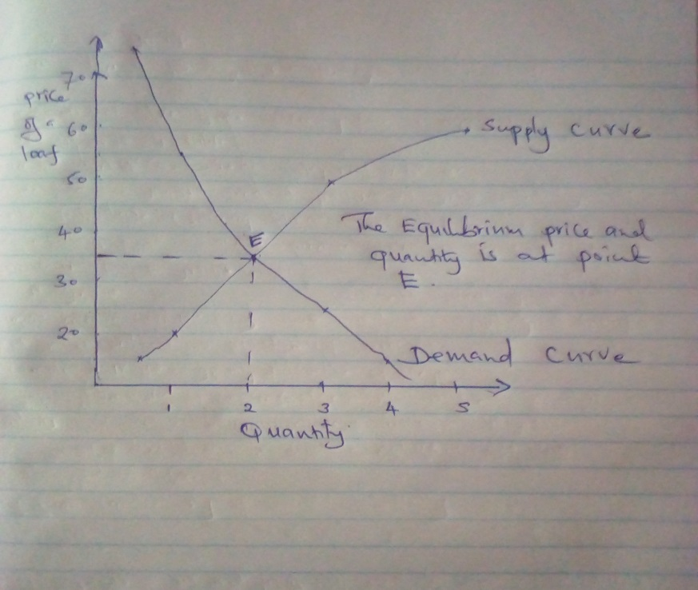

In this graph the equilibrium price and quantity demanded is at point E whereby, the units of the quantity demanded and supplied are 3 while price for these united demanded and supplied is $ 40.

3- The market for marbles is represented in the graph. What is the total producer surplus? The total consumer surplus? What are the total gains from trade?
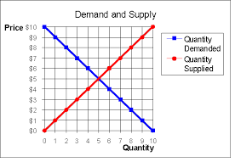
Total producer surplus is the price difference benefit that producer gains from trade and it are realized whereby the producer’s price is lower than the existing market prices. In this case the total producer surplus in this case can be derived ½ base x height .i.e. ½ x5x5=12.5
The total consumer surplus is the total measure of the economic benefit derived by the consumer in trade. It is determined by analyzing the difference between the market price and what consumers are willing to pay for products (Brown & Troutt, 2018). In our case, total consumer surplus by ½ x5x5=12.5
The total gains from trade are the sum of consumer surplus and the producer’s surplus. In this cases now the total gains from trade is 12.5+12.5 =25

4- Explain how a movement along the demand curve and a shift of the supply curve are related.
The movement of demand curve is related with the shift of the supply curve in different ways. Usually, when there is a high demand for products in the market it creates an increased supply for the quantity demanded. Therefore an upward movement of a demand curves makes a supply curve to shift to the right hand side due to the increased supply resulting from high demand (Larsen, & Fredborg, 2018) Also the downward movement of the demand curve leads to shift of the supply curve to the left side which means there is decreased demand and thus the quantity supplied decreases.

5- In a market for oranges, there are two types of buyers: high-value buyers, who use the oranges to make orange juice, and low value buyers, who use the oranges for cow feed.

When the price of oranges is high, who buys oranges?
High values buyers are those buyers who buys products at an existing price and they don’t wait price for the product to fall. In our cases, the high value buyers will buy oranges to make orange juice and they will have no other alternative for making orange juice. They have an option of selling this orange juice at high price for them to make profit.
When the price of oranges is low, who buys oranges?
When price of orange is low the high can buy oranges to be used cow feeds.
6- A farmer has three fields. On each field he can grow soybeans OR wheat. Each field can produce EITHER this many bushels of soybean or of wheat.

Field | Bushels of soybeans | Bushels of wheat
A | 10 | 10
B | 12 | 7
C | 6 | 9

If the price of soybeans is $10 per bushel and the price of wheat is $12 per bushel, which fields does the farmer grow soybeans on?
The farmer will grow soybeans on farms A and B because the expected income in these fields is $100 and $ 120 in farm A and B respectively with total earnings of $220.
If the price of soybeans is $6 per bushel and the price of wheat is $12 per bushel, which fields does the farmer grow soybeans on?
If the price of soybeans is $6 the farmer will choose fields A and B. The famer will earn in long-run $60 from field A and $72 from field B giving a total earning of $132.
If the price of soybeans is $19 per bushel and the price of wheat is $12 per bushel, which fields does the farmer grow soybeans on?
The farmer will grow soybeans on fields A and B and earn $109 from field A and $120 from filed B respectively with a total earning of $310.

References
Brown, L. K., & Trout, E. (2018). A re-analysis of the trade and welfare effects of export subsidies. Applied Economics Letters, 25(6), 420-424.
Larsen, H., & Fredborg, J. (2018). An Analytical Framework for Welfare Analysis of Trade.

